**DATA MODELLER ER-DIAGRAMS:**

* **B.Rishitha, 192324130**

**HOCKEY:**

Logical model:

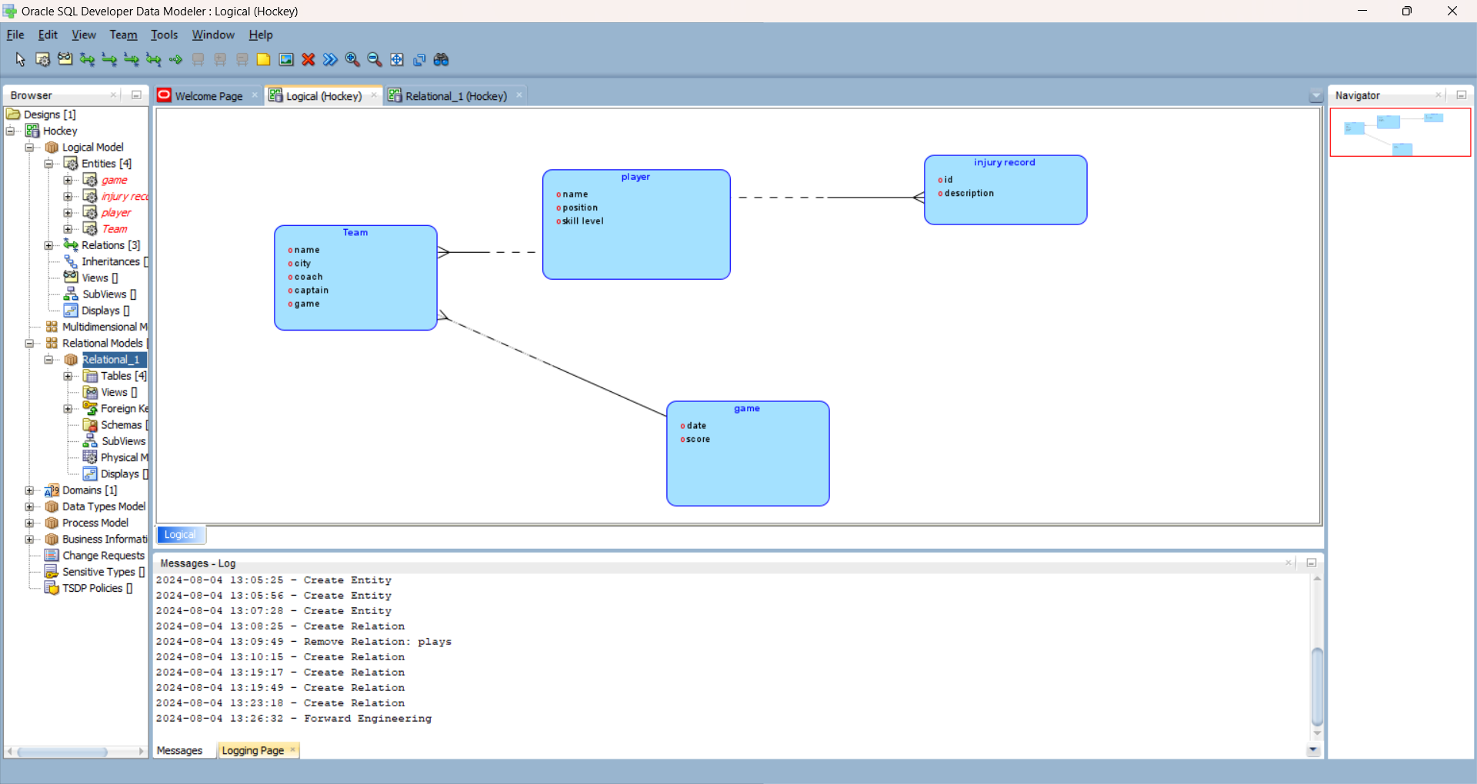

Relational model:

